This diagram indicates the “ideal” posture and as such can be used as a basis for adjustment of your work station. Your desk, chair and screen (VDU) have a range of adjustments to assist you to “fit” your work station to your personal needs. Please familiarise yourself with these adjustments.

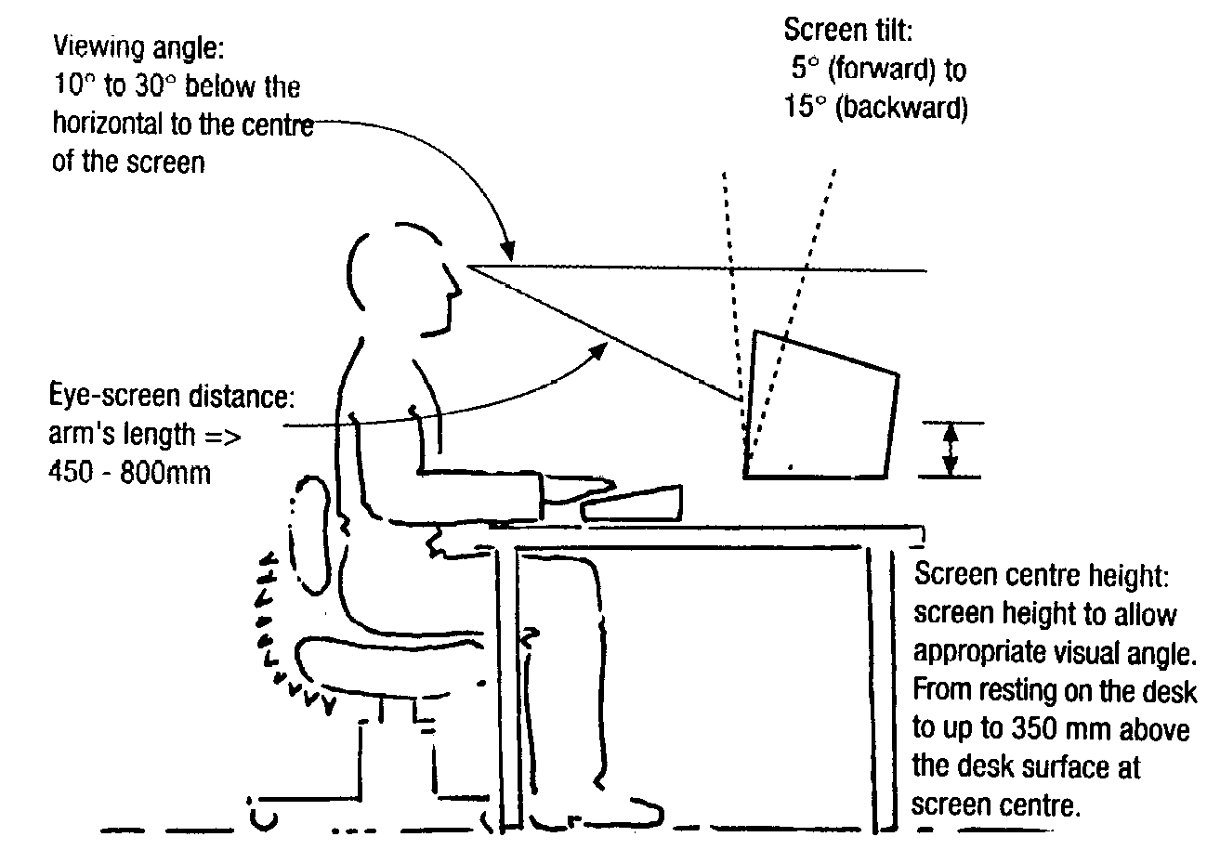

These diagrams (below) indicate the measurements required for VDU workstations and supporting equipment. If your current workstation clearly does not meet these minimum requirements please comment on where the deficiency lies in the last section of the accompanying form.

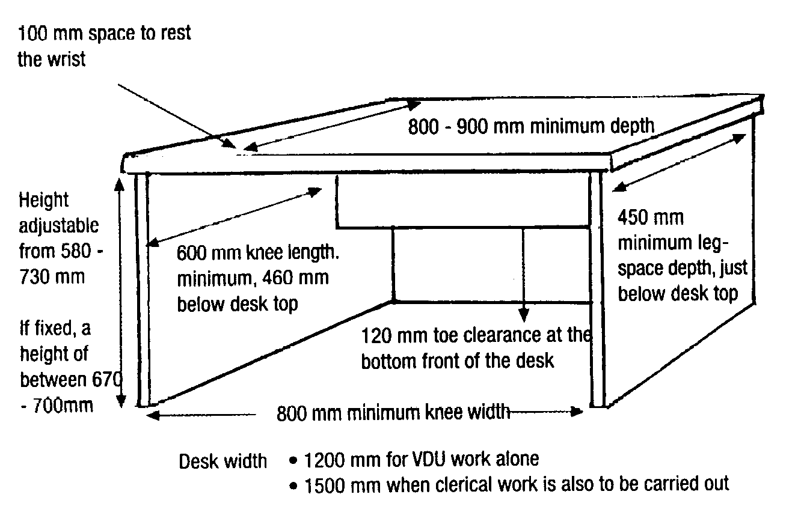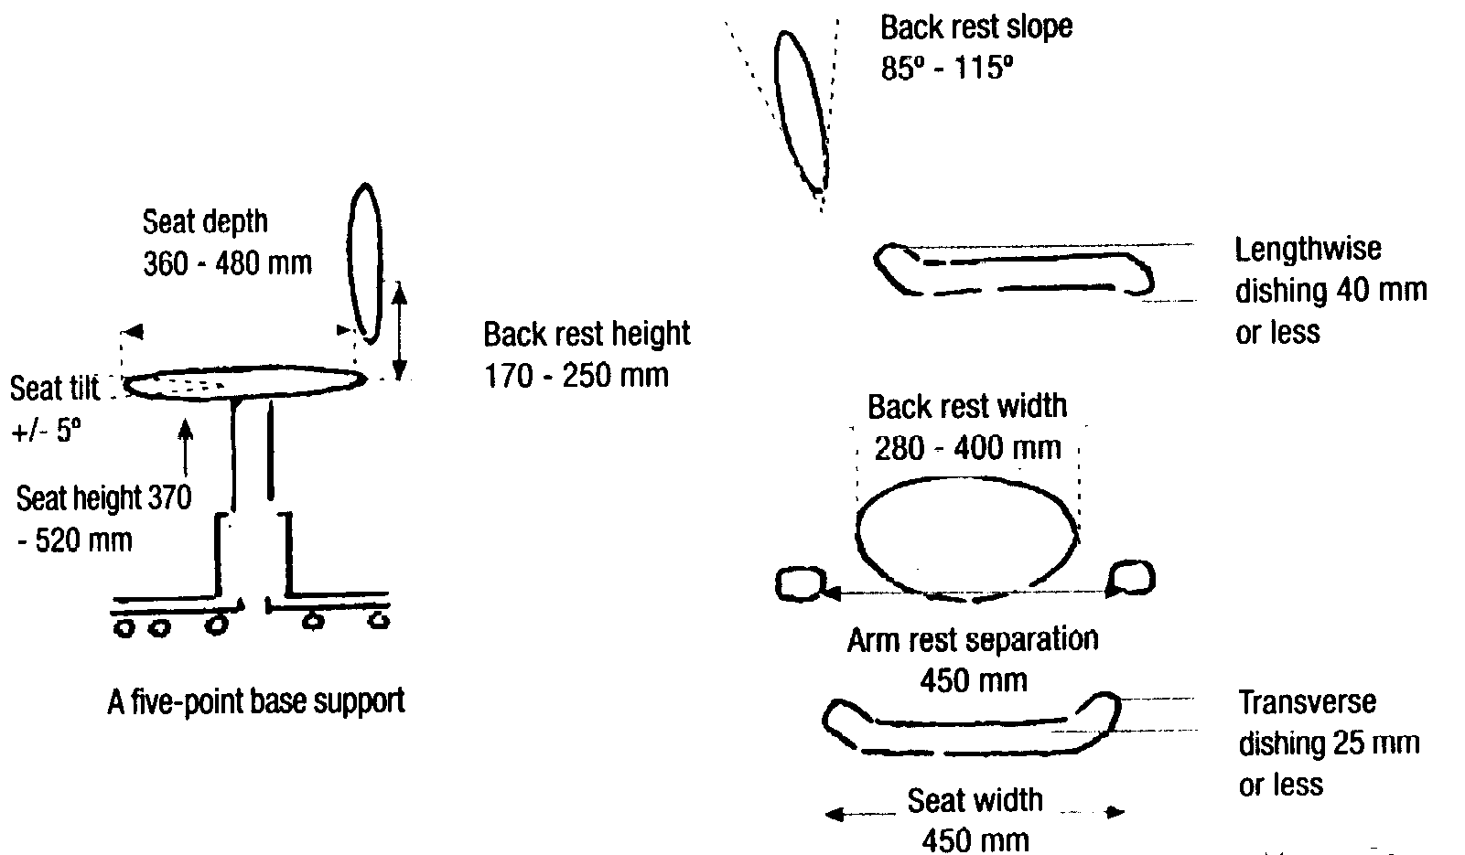

Name of Employee

Work Area

Date

Is the work station used by more than 1 person and/or Do you use more than 1 work station If YES, specify locations _________________________________________________________

Subjective Questions | YES | NO
Do you think your work station is comfortable?
Do you know how you adjust your chair?
Do you know how to adjust your work station?
Do you know how to identify the early symptoms of OOS?
Do you take breaks from your keyboard work at set times?

Work station Components | YES | NO
Is your chair adjustable for height?
Is your chair adjustable for angle?
Is your chair stable?
Does our chair move easily on the floor?
Is your table adjustable?
Is there adequate desk space?
Is there adequate leg room?
Is there easy access in & out of your desk?
Is the VDU keyboard adjustable for height, angle & viewing distance?
Is a copy holder provided?
For what proportion of the VDU use time do you use a mouse?
Is a mouse rest required?
Is your workstation positioned so that glare is not a problem?

Employee Technique | YES | NO
Do you avoid the use of a single posture?
Do you avoid the use of prolonged abnormal posture?
Do you “lift & twist” e.g. opening a lower desk drawer?
When operating, do you have relaxed shoulders?
Do your elbows swing free?
Do you avoid bending up (extending) the wrist?
Do you avoid bending the wrist sideways (deviation)?
Are forward reaches avoided by work design?
Do you avoid tilting the head forward to look down?

Work Organisation | YES | NO
Are you able to vary your work tasks?
Are you able to prioritise your workload yourself?
Are you freely able to discuss conflicting workloads with your Supervisor?
Have any of the above issues caused you pain or discomfort?

How much of your working day do you use a VDU?
How frequently are you asked to meet unscheduled deadlines?
How many hours Overtime have you worked in the last week?
How many hours Overtime have you worked in the last month?

Have you ever experienced any pain or discomfort as a result of operating a VDU?

Use the diagram below to shade the areas most affected. Describe how the pain / discomfort feel.

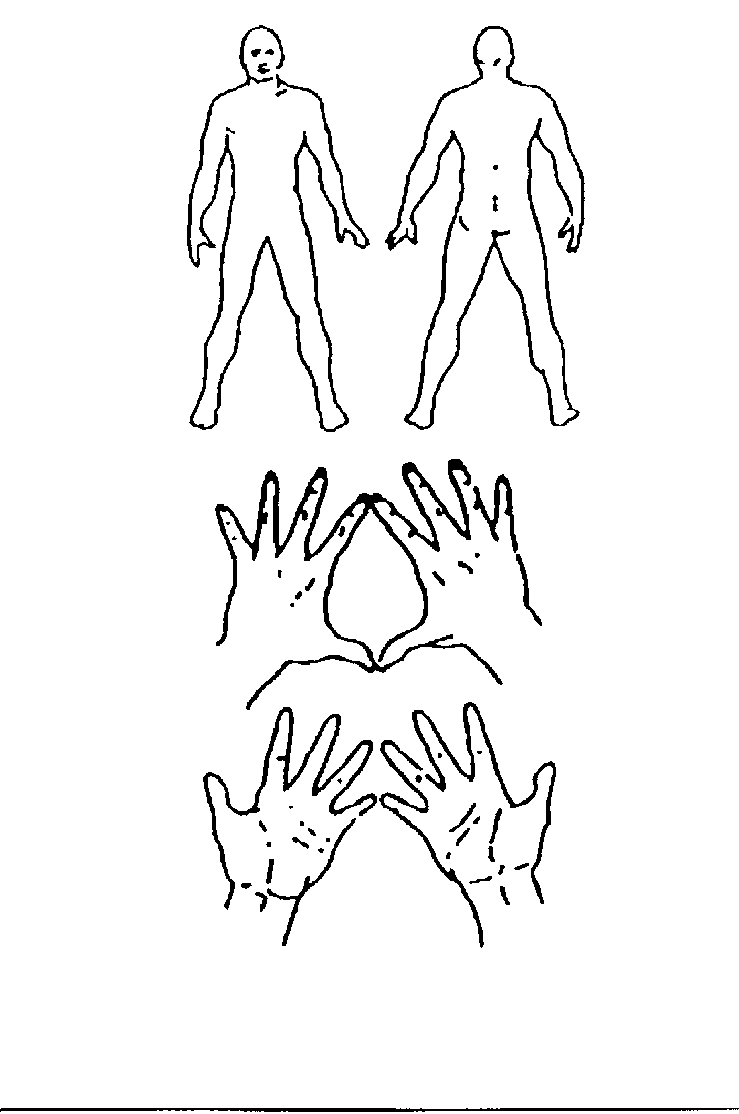

Decribe what improvements can you see your work station requires?

